Source Apportionment and Concentration of Potentially Toxic Elements in Surface Water and Sediments of Okulu-Aleto River, Rivers State Nigeria
^{*ab}Afolabi, O. O., ^{ac}Hart, A. I. & ^{ad}Nwankwoala, H. O.

ªInstitute of Natural Resources, Environment and Sustainable Development, University of Port Harcourt, Nigeria
^{b}Institute of STEM Innovation and Excellence, Nigeria
^{c} Department of Animal and Environmental Biology, University of Port Harcourt, Port Harcourt, Nigeria
^{d} Department of Geology, Rivers State University, Port Harcourt, Nigeria
*Corresponding Author: Afolabi, O. O. (omobolaji_afolabi@uniport.edu.ng)

Supplementary Table (ST) 1: Sampling Points Details and Geographical Information
Description | Code | Latitude | Longitude
Surface Water Details
Point Source | PS | 4° 48' 40.500" N | 7° 6' 29.900" E
Surface Water Point 1 | SWP1 | 4° 48' 29.177" N | 7° 6' 2.543" E
Surface Water Point 2 | SWP2 | 4° 48' 28.399" N | 7° 5' 28.621" E
Surface Water Point 3 | SWP3 | 4° 48' 54.573" N | 7° 4' 40.533" E
Sediment Details
Sediment Point 1 | SDP1 | 4° 48' 23.547" N | 7° 6' 3.276" E
Sediment Point 2 | SDP2 | 4° 48' 22.635" N | 7° 5' 28.416" E
Sediment Point 3 | SDP3 | 4° 48' 48.379" N | 7° 4' 41.823" E

ST 2: Instrument operating conditions for PTEs in samples from Okulu-Aleto River, Rivers State Nigeria Based on Flame Atomic Absorption Spectroscopy (FAAS).
HMs | Wavelength (nm) | Slit width (nm) | Lamp current (mA) | Lamp energy (eV) | Flame system
Cu | 357.9 | 0.5 | 4 | 3.32 | Air-Acetylene
Zn | 213.9 | 1 | 5 | 2.81 | Air-Acetylene
Pb | 217 | 0.7 | 3 | 2.56 | Air-Acetylene
Cd | 228.9 | 0.7 | 2 | 2.9 | Air-Acetylene
Fe | 248.3 | 0.2 | 7 | 2.8 | Air-Acetylene
Cr | 357.9 | 0.7 | 2 | 3.18 | Air-Acetylene
Ni | 232 | 0.2 | 4 | 2.96 | Air-Acetylene

SI: Measured limit of detection (LOD), limit of quantification (LOQ), regression coefficient, relative standard deviation (%RSD), and recovery (%) values for Surface Water
PTEs | LOD  (mg/l) | LOQ  (mg/l) | Calibration  range (mg/l) | Calibration  equation | Correlation  Coeff. (R²) | %RSD  (Min.-Max.) | %Recovery  (Min.-Max.)
Fe | 0.012 | 0.071 | 0.1 - 20.0 | y = 0.0005x + 0.0001 | 0.996 | 3.2-10.4 | 88-98
Cu | 0.006 | 0.022 | 0.02 – 10.0 | y = 0.0004x - 0.0012 | 0.999 | 7.6-11.9 | 87-99
Zn | 0.055 | 0.16 | 0.2 - 10.0 | y = 0.0007x + 0.0022 | 0.997 | 4.1-7.7 | 86-98
Cr | 0.001 | 0.012 | 0.01 - 1.20 | y = 0.2425x - 0.0041 | 0.997 | 4.9-11.2 | 87-98
Pb | 0.004 | 0.011 | 0.01 - 10.0 | y = 0.0005x - 0.0001 | 0.997 | 1.9-5.3 | 90-95
Cd | 0.005 | 0.04 | 0.02 - 1.20 | y = 0.0165x + 0.0004 | 0.999 | 3.6-9.0 | 93-99
Ni | 0.024 | 0.061 | 0.1 - 10.00 | y = 0.0017x - 0.0065 | 0.998 | 5.2-10.8 | 85-93
Remark: PETs = Potentially Toxic Elements

ST 4: Measured limit of detection (LOD), limit of quantification (LOQ), regression coefficient, relative standard deviation (%RSD), and recovery (%) values for Sediment
PTEs | LOD  (mg/l) | LOQ  (mg/l) | Calibration  range (mg/l) | Calibration  equation | Correlation  Coeff. (R²) | %RSD  (Min.-Max.) | %Recovery  (Min.-Max.)
Fe | 0.022 | 0.072 | 0.1 - 20.0 | y = 0.0005x + 0.0001 | 0.995 | 3.2-10.4 | 87-98
Cu | 0.006 | 0.021 | 0.02 – 10.0 | y = 0.0004x - 0.0012 | 0.998 | 8.6-11.8 | 89-98
Zn | 0.054 | 0.17 | 0.2 - 10.0 | y = 0.0007x + 0.0022 | 0.999 | 3.9-7.5 | 88-99
Cr | 0.012 | 0.037 | 0.05 - 6.00 | y = 0.0111x - 0.0059 | 0.999 | 9.2-12.3 | 85-99
Pb | 0.002 | 0.007 | 0.01 - 10.0 | y = 0.0005x - 0.0001 | 0.997 | 0.3-7.9 | 90-94
Cd | 0.006 | 0.02 | 0.02 - 1.20 | y = 0.0165x + 0.0004 | 0.995 | 3.6-9.0 | 92-99
Ni | 0.006 | 0.02 | 0.02 - 1.00 | y = 0.0098x - 0.0033 | 0.995 | 3.1-7.4 | 94-97
Remark: PETs = Potentially Toxic Elements

Table 4: Rotation component matrix of PTEs across the Environmental Mediums
 | Surface Water |  |  |  | Sediment
 | PC 1 | PC 2 | PC 3 |  | PC 1 | PC 2 | PC 3
Cd | 0.085 | 0.995 | -0.061
Ni | 0.760 | 0.529 | -0.355
Cr | 0.776 | 0.445 | -0.446 |  | 0.982 | 0.068 | -0.178
Cu | 0.993 | -0.115 | 0.023 |  | -0.079 | 0.996 | -0.036
Zn | -0.953 | -0.228 | 0.159 |  | 0.110 | 0.991 | 0.074
Pb | 0.971 | 0.150 | -0.162 |  | 0.982 | -0.185 | 0.022
Fe | -0.128 | -0.075 | 0.989 |  | 0.927 | 0.194 | 0.322
Eigenvalues | 4.851 | 1.252 | 0.036 |  | 2.828 | 2.042 | 0.130
% of Variance | 57.716 | 22.301 | 19.409 |  | 56.115 | 41.033 | 2.852
Cumulative % | 57.716 | 80.016 | 99.425 |  | 56.115 | 97.148 | 100.00

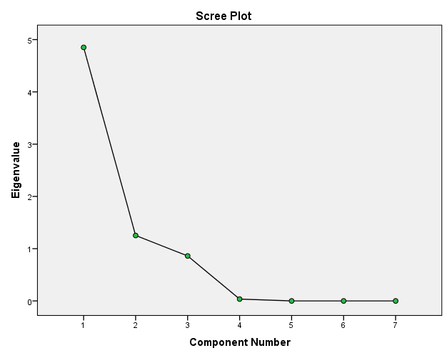

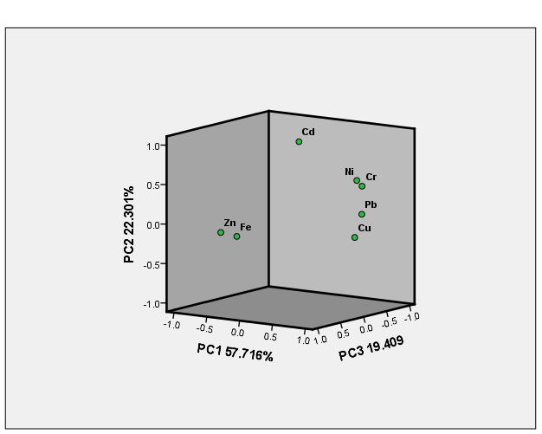
Supplementary Figure (SF) 1: Scree plot of eigenvalues after PCA and rotated component matrix of PTEs in Surface Water
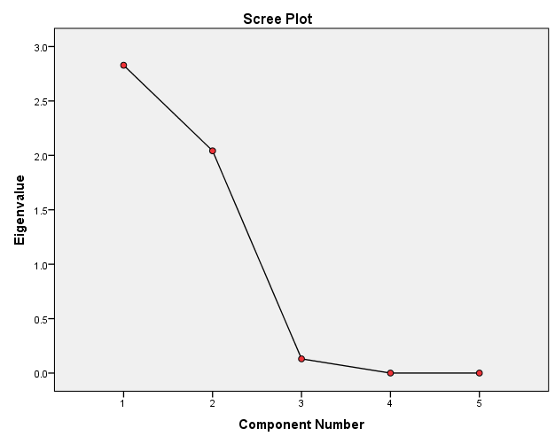
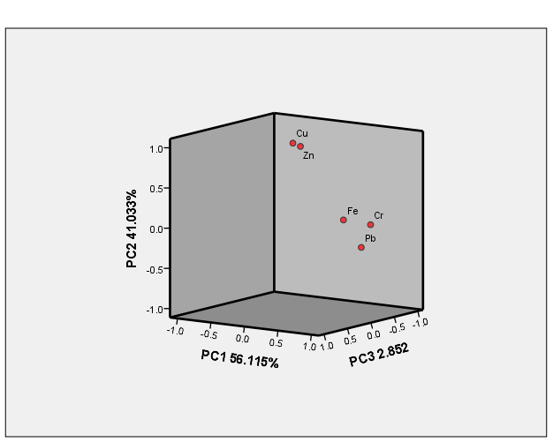
SF 2: Scree plot of eigenvalues after PCA and rotated component matrix of PTEs in Sediment

